**Bootstrap icons**

Bootstrap is CSS library.

In order to work with bootstrap icons use the following steps

1. Install nodejs
   1. To use package manger called npm (node package manager), it is used for managing packages(libraries)

**Note: npm stands for node package manger**

**How verify node is installed or not?**

1. Open command prompt

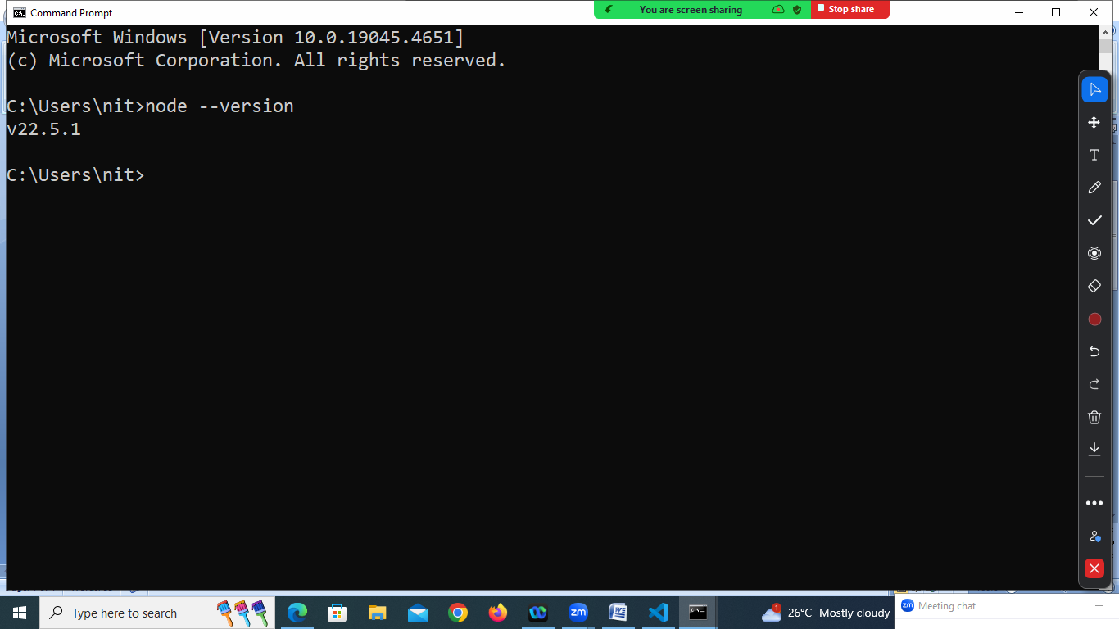

Open vscode

Open terminal

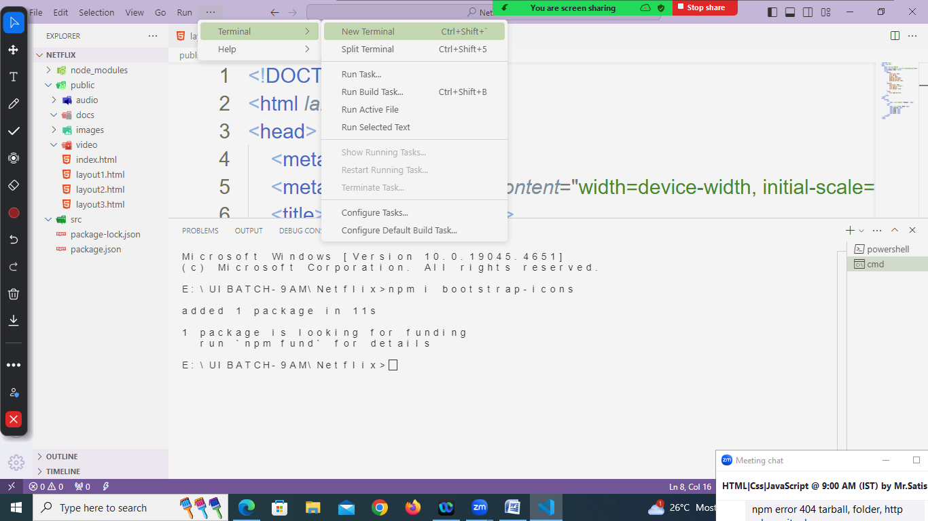

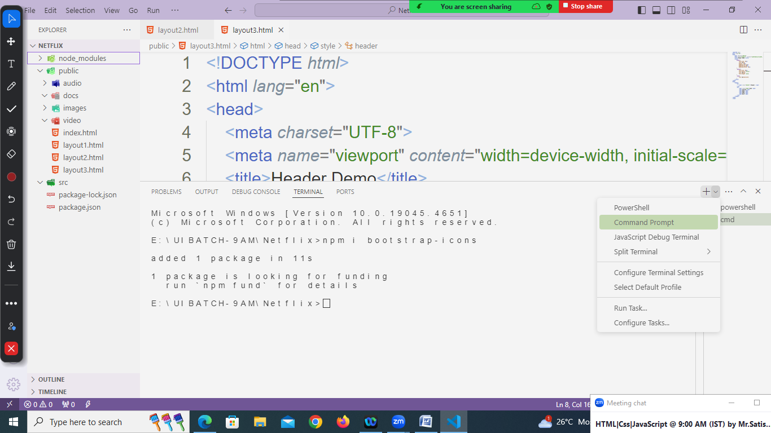

**CSS display styles**

display:none : hide element

display:inline : it will display element side by side without effects (size,format)

display:block : it will display element one after another

display:inline block : it will display elements side by side with effects

(size and format)

Display:flex : it can display inline or block

Flex-direction : row

Flex-direction: column

<!DOCTYPE *html*>

<html *lang*="en">

<head>

    <meta *charset*="UTF-8">

    <meta *name*="viewport" *content*="width=device-width, initial-scale=1.0">

    <title>Header Demo</title>

    <link *rel*="stylesheet" *href*="../node_modules/bootstrap-icons/font/bootstrap-icons.min.css">

    <style>

        header{

            font-size: 30px;

            margin: 20px;

            padding-left:20px;

            padding-top:20px;

            padding-bottom: 20px;

            display: flex;

            flex-direction: row;

            justify-content:space-evenly;

        }

        .banner{

            font-size: 50px;

            font-family:"arial";

            font-weight: bold;

        }

    </style>

</head>

<body>

    <header>

        <div>

            <span *class*="banner">Shopper.</span>

        </div>

        <div >

          <nav>

            <span>Home</span>

            <span>Catalog</span>

            <span>Shop</span>

            <span>Page</span>

            <span>Blog</span>

            <span>Docs</span>

        </nav>

        </div>

        <div>

            <span *class*="bi bi-search"></span>

            <span *class*="bi bi-person"></span>

            <span *class*="bi bi-heart"></span>

            <span *class*="bi bi-cart"></span>

        </div>

    </header>

</body>

</html>